Lab-9

Memory allocation:
#include <stdio.h>
#include <string.h>

#define MAX_BLOCKS 20
#define MAX_PROCESSES 20

void printAllocation(int processSize[], int n_processes, int allocation[]) {
printf("\nProcess No.\tProcess Size\tBlock No.\n");
for (int i = 0; i < n_processes; i++) {
printf(" %d\t\t%d\t\t", i + 1, processSize[i]);
if (allocation[i] != -1) {
printf("%d\n", allocation[i] + 1);
} else {
printf("Not Allocated\n");
}
}
}

void firstFit(int blockSize[], int m_blocks, int processSize[], int n_processes) {
int allocation[MAX_PROCESSES];
int blocks[MAX_BLOCKS];

memcpy(blocks, blockSize, sizeof(blocks[0]) * m_blocks);
memset(allocation, -1, sizeof(allocation));

for (int i = 0; i < n_processes; i++) {
for (int j = 0; j < m_blocks; j++) {
if (blocks[j] >= processSize[i]) {
allocation[i] = j;
blocks[j] -= processSize[i];
break;
}
}
}

printf("\n--- First Fit Allocation ---");
printAllocation(processSize, n_processes, allocation);
}

void bestFit(int blockSize[], int m_blocks, int processSize[], int n_processes) {
int allocation[MAX_PROCESSES];
int blocks[MAX_BLOCKS];

memcpy(blocks, blockSize, sizeof(blocks[0]) * m_blocks);
memset(allocation, -1, sizeof(allocation));

for (int i = 0; i < n_processes; i++) {
int bestIdx = -1;
for (int j = 0; j < m_blocks; j++) {
if (blocks[j] >= processSize[i]) {
if (bestIdx == -1 || blocks[j] < blocks[bestIdx]) {
bestIdx = j;
}
}
}

if (bestIdx != -1) {
allocation[i] = bestIdx;
blocks[bestIdx] -= processSize[i];
}
}

printf("\n--- Best Fit Allocation ---");
printAllocation(processSize, n_processes, allocation);
}

void worstFit(int blockSize[], int m_blocks, int processSize[], int n_processes) {
int allocation[MAX_PROCESSES];
int blocks[MAX_BLOCKS];

memcpy(blocks, blockSize, sizeof(blocks[0]) * m_blocks);
memset(allocation, -1, sizeof(allocation));

for (int i = 0; i < n_processes; i++) {
int worstIdx = -1;
for (int j = 0; j < m_blocks; j++) {
if (blocks[j] >= processSize[i]) {
if (worstIdx == -1 || blocks[j] > blocks[worstIdx]) {
worstIdx = j;
}
}
}

if (worstIdx != -1) {
allocation[i] = worstIdx;
blocks[worstIdx] -= processSize[i];
}
}

printf("\n--- Worst Fit Allocation ---");
printAllocation(processSize, n_processes, allocation);
}

int main() {
int m_blocks, n_processes;
int blockSize[MAX_BLOCKS], processSize[MAX_PROCESSES];

printf("Enter the number of memory blocks: ");
scanf("%d", &m_blocks);
printf("Enter the size of each block:\n");
for (int i = 0; i < m_blocks; i++) {
printf("Block %d: ", i + 1);
scanf("%d", &blockSize[i]);
}

printf("\nEnter the number of processes: ");
scanf("%d", &n_processes);
printf("Enter the size of each process:\n");
for (int i = 0; i < n_processes; i++) {
printf("Process %d: ", i + 1);
scanf("%d", &processSize[i]);
}

firstFit(blockSize, m_blocks, processSize, n_processes);
bestFit(blockSize, m_blocks, processSize, n_processes);
worstFit(blockSize, m_blocks, processSize, n_processes);

return 0;
}

OUTPUT:
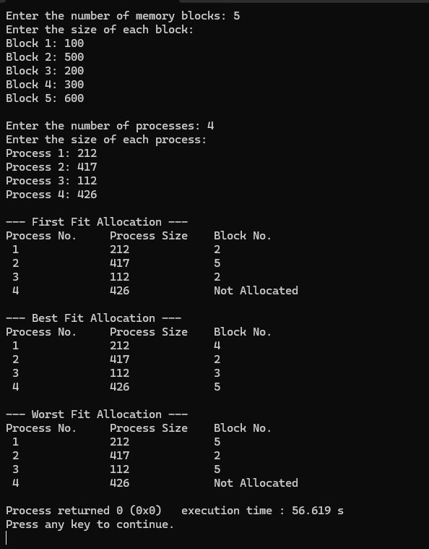

Observation:
